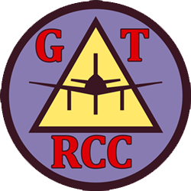
New Member
Application

Name:
Address:
City:
State:
Zip:
Phone:
Email:
Date of Birth:
AMA Number:

☐ Yes, I would like to receive the monthly newsletter

*Individual FAA Registration is required by the FAA for UAS operation. FAA Registration is encouraged but not required as a prerequisite for membership at GTRCC.

